01.01.23

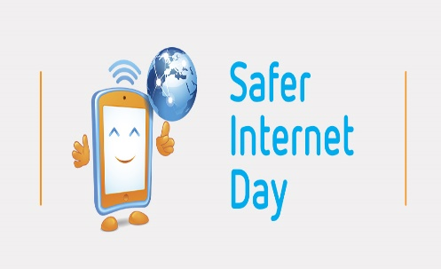
Dear Parents and Carers,

Safer Internet Day 2023 will take place on the 7th of February 2023, with learning in every class based around the theme ‘Want to talk about it? Making space for conversations about life online’. Our school council will be presenting in assembly and they have also made some posters which we will upload to the school website and display around school with top tips on how to stay safe online.
There is lots of information available to help you manage internet safety effectively at home. Please find below some interesting information taken from https://saferinternet.org.uk/
Be positive and open minded about the internet
It’s important to recognise the exciting opportunities that going online can offer children and young people. Although your children may use the internet differently to you, their experiences are still significant.
If your child mentions something you haven’t heard of, ask them to show you, or explain in more detail, or you may need to do your own research. Try to keep conversations broad, and value their opinions when they’re talking about what they enjoy doing, to show that you are interested in all aspects of their online world.

Create a safe space for conversations
Look for opportunities to talk together. Sometimes, talking face-to-face can feel difficult, so talking alongside each other when out for a walk, or travelling in the car for example, are options that might make it easier.
The environment needs to be right; free from distractions, so that your child has your undivided attention. Remind them often that they can talk to you about anything, no matter how difficult, and that they will not be judged or blamed.
Your child might not be ready to talk about something straight away, so show them that you are there to listen whenever they are ready.

Be proactive
Working together to create an agreement, outlining how the internet and technology will be used within the family, is a useful way to set clear expectations and boundaries for your children.
You might include time spent online; who your children can communicate with; appropriate apps and games; and why safety tools are helpful to block and report inappropriate content.
Ask your child what they would do if something went wrong online and they needed help, and reinforce the importance of telling an adult as soon as anything happens that makes them feel upset, worried, or uncomfortable in any way.

If you have any issues with Internet safety or would like any more information about your child using the internet safely. Please do not hesitate to contact our designated Safe-guarding Leads in school who will be happy to help you:
Mrs Jackson: Designated Safe-guarding Lead
Miss Fletcher: Deputy Designated Safe-guarding Lead

Psalm 55:22
Cast your cares on the Lord
and he will sustain you;
he will never let
the righteous be shaken.

